During coronavirus, Banking Trojans use fake coronavirus propaganda page to conduct phishing attacks. Banking Trojans will steal the victim's credit card information, SMS, contacts, call records, etc.

Fishing Domain：

[https://canada-alert-covid19.com/#](https://canada-alert-covid19.com/)

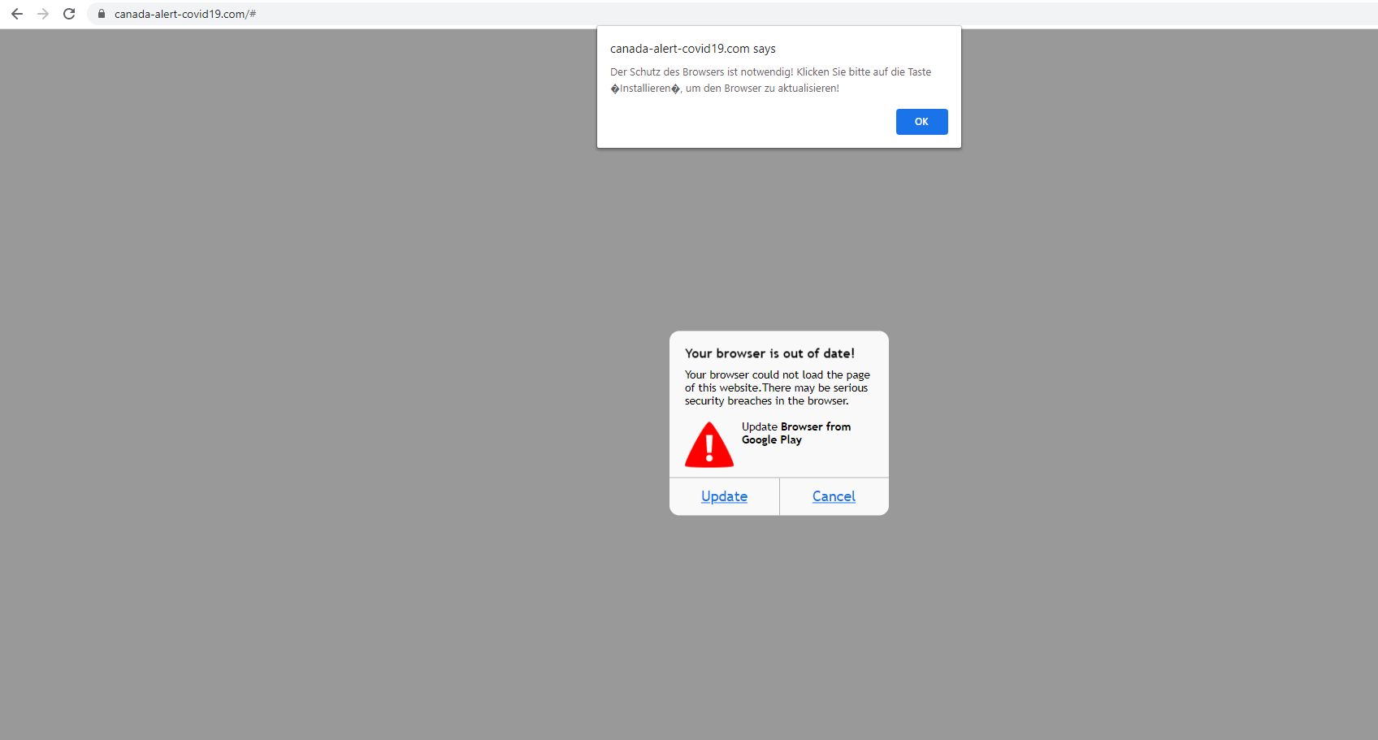

Download Banking Trojan

<https://canada-alert-covid19.com/ChromeUpdate.apk>

Indicators of Compromise:

|  |  |  |
| --- | --- | --- |
| Sha256 | Downloadd Name | Trend Micro Pattern Detection |
| fe5c9cab4f91b621eac9cc9b95984bfc8263d4d8bf68120814777fd92b85188d | ChromeUpdate.apk | AndroidOS_Hqwar.HRXI |